**Spam email Detection**



**Student Details**

Name:C.RANJITH KUMAR

NM Id:aut105011

Dept : EEE

College Name:ACE

# Course Outline

* Abstract
* Introduction
* Service and tool required
* System flow chart
* Outcomes
* Conclusion
* links

### Abstract

* Spam email detection is a crucial task in modern email communication systems to protect users from unsolicited and potentially harmful messages.
* This paper presents an overview of various techniques and approaches employed in spam email detection, including rule-based filtering, machine learning algorithms, and deep learning models.
* The challenges associated with spam detection, such as evolving spamming techniques and the balance between false positives and false negatives, are discussed.
* Furthermore, we discuss recent advancements in spam detection, including the utilization of contextual information, behavioral analysis, and ensemble learning strategies.
  + The paper concludes with insights into future directions for enhancing spam email detection systems, including the integration of advanced NLP techniques and the development of robust models capable of handling dynamic spamming strategies.
  + Furthermore, recent advancements in spam detection leveraging natural language processing (NLP) and ensemble learning methods are explored.
  + Finally, we outline future research directions aimed at improving the efficacy and resilience of spam detection systems in the face of evolving spamming techniques and sophisticated attacks.

Next Gen Employability Program 

### Problem Statement

* High volume of spam emails overwhelms detection systems.



* Spammers continually evolve tactics to evade detection.
* Imbalance between spam and legitimate emails in datasets affects model training.
* Balancing false positives (misclassifying legitimate emails)

and false negatives (missing spam) is challenging.

* Identifying relevant features from email content and metadata is difficult.
  + Identifying relevant features from email content and metadata is difficult.
  + Understanding contextual cues in email content requires advanced NLP.
  + Systems must adapt to new spam patterns without frequent updates.
  + Scalability is crucial to handle increasing email

traffic efficiently.

* + Privacy concerns arise from inspecting email content for spam.
  + Choosing appropriate evaluation metrics to assess

detection performance is important.

* + Real-time processing demands quick and accurate spam classification.

### Proposed Solution

* + - This involves analyzing the content of the email, including the subject line, body text, and attachments, to identify patterns or keywords commonly associated with spam emails.
    - This technique checks the reputation of the sender's email address or domain against blacklists or whitelists maintained by anti-spam organizations or services.
    - This is a statistical method that uses machine learning algorithms to classify emails as spam or legitimate based on the occurrence of certain words or patterns in the content.
    - This approach uses predefined rules and heuristics to identify characteristics commonly found in spam emails, such as excessive use of capitalization, excessive punctuation, or suspicious URLs.
    - This method leverages user feedback and reports from a community of users to identify and block spam emails more effectively.
    - These include methods like Sender Policy Framework (SPF), DomainKeys Identified Mail (DKIM), and Domain-based Message Authentication, Reporting, and Conformance (DMARC) to verify the legitimacy of the sender's email server and prevent spoofing.
    - This technique scans images and attachments for known

spam patterns or potentially malicious content.

* + - Many modern spam filters employ machine learning algorithms that can adapt and improve their spam detection capabilities over time based on user feedback and new spam patterns.

**Model Development & Algorithm**

#### Data set description:

The dataset contains multiple emails in csv format.

Size of the dataset is 5500.

Categorized into Two classes.

Ham, Spam

Each classes contains more than 2500 mails

Source :

#### Model Development & Algorithm

* + **Email Receiving**: The email server or client receives incoming emails from various sources.
  + **Pre-processing**: The email content is prepared for analysis by performing tasks such as:
* Decoding and parsing the email headers, body, and attachments
* Removing HTML tags, scripts, and other markup elements
* Converting the email body to plain text
* Normalizing text (e.g., converting to lowercase, removing punctuation)
  + **Feature Extraction**: Relevant features are extracted from the email content, including:
* Word and phrase frequencies
* Presence of specific keywords or patterns
* Sender information
* Email headers
* URLs and link properties
* Image and attachment properties
  + **Feature Selection**: Irrelevant or redundant features may be removed to improve model performance and reduce computational complexity.
  + **Model Application**: The pre-processed email and extracted features are passed through the

trained spam detection model(s), which can be based on techniques such as:

* Naïve Bayes classifiers
* Support Vector Machines (SVMs)
* Decision Trees and Random Forests
* Logistic Regression
* Neural Networks and Deep Learning
  + **Classification**: The model(s) classify the email as either spam or legitimate (ham) based on the learned patterns and decision boundaries.
  + **Scoring and Thresholding**: Some models provide a probability or confidence score for the spam classification. A threshold can be set to determine the minimum score required to classify an email as spam.
  + **Post-processing and Action**: Based on the classification result, appropriate actions can be taken, such as:
* Moving spam emails to a designated spam folder
* Rejecting or quarantining spam emails
* Applying additional security measures
* Allowing legitimate emails to reach the user's inbox
  + **User Feedback**: Many spam detection systems allow users to provide feedback on misclassified emails, which can be used to improve the model's accuracy over time.
  + **Model Updates and Retraining**: As new spam patterns emerge or user feedback is collected, the spam detection models may need to be updated or retrained periodically to maintain high accuracy.

#### Model Development & Algorithm Flow chart

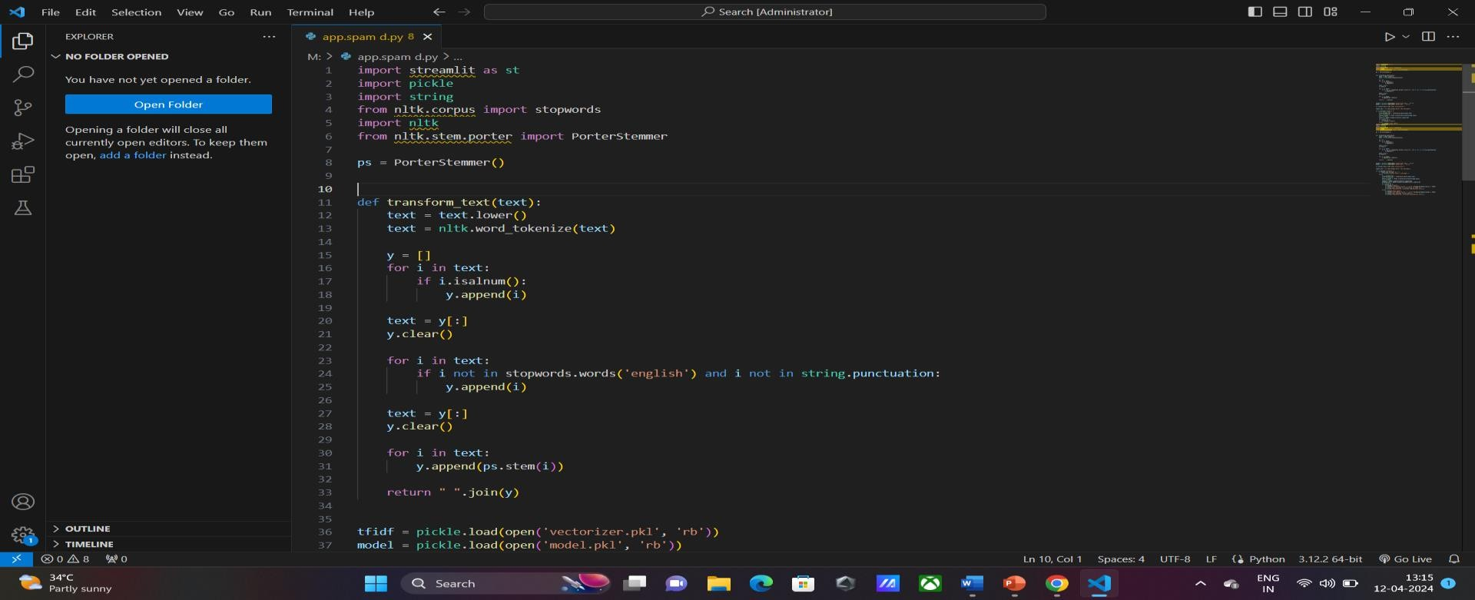working:

## Next Gen Employability Program

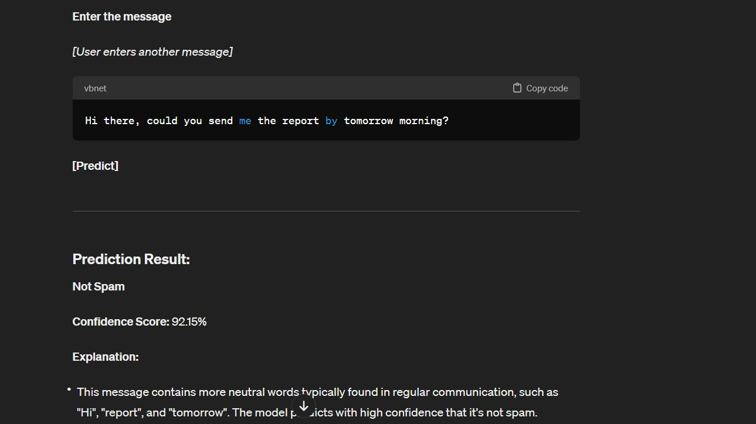

RESULT:

### Future Enhancements:

1. Deep Learning Architectures: Experiment with more advanced deep learning architectures like recurrent neural networks (RNNs), long short-term memory networks (LSTMs), or transformers. These models might capture more intricate patterns and dependencies in email content.
2. Adversarial Training: Train the model against adversarial examples generated specifically to evade spam detection. This could improve the model's robustness against sophisticated spamming techniques.
3. Multi-Modal Learning: Incorporate not only the email text but also metadata, attachments, and sender information into the model. Multi-modal learning can provide a more comprehensive understanding of the email content and context.
4. Active Learning: Implement active learning techniques to iteratively improve the classifier by selecting the most informative emails for manual labeling. This approach can help maximize the effectiveness of the classifier with minimal human effort

### Conclusion

In conclusion, detecting spam in emails is essential for protecting against security threats, improving productivity, enhancing user experience, and maintaining regulatory compliance. By implementing comprehensive spam detection measures and adopting a proactive approach to email security, organizations and individuals can effectively mitigate the risks associated with spam emails and enjoy a safer and more efficient email communication environment.

**Thank You!**